Online Book Publishing and Sales Platfrom - Database0 Documentation

Database name : Books_publishing_system

Creating Tables:

CREATE TABLE Publisher(
publisher_id int primary key,
name varchar(250) not null,
contact_details varchar(250)
);

Creating a Publisher Table and the columns are publisher_id data type Int (Primary key), name data type varchar, contact_details data type varchar.

CREATE TABLE Book(
book_id int primary key,
title varchar(250) not null,
ISBL varchar(100) not null,
edition int not null,
publication_year int,
price decimal(10, 2),
publisher_id int,
foreign key (publisher_id) references Publisher(publisher_id) on delete cascade
);

Creating a Book Table and the columns are book_id data type Int (Primary key), title data type varchar, ISBL data type Int, edition data type Int, publication_year data type Int, price data type decimal, publisher_id data type Int (Foreign key).

CREATE TABLE Genere(
genere_id int primary key,
genere_name varchar(250) not null
);

Creating a Genere Table and the columns are genere_id data type Int (Primary key), genere_name data type varchar.

CREATE TABLE Book_genere(
book_id int,
genere_id int,
primary key(book_id, genere_id),
foreign key (book_id) references Book(book_id),
foreign key (genere_id) references Genere(genere_id)
);.

Creating a Book_genere Table and the columns are book_id data type Int (Primary key and Foreign key), genere_id data type int(Primary key).

CREATE TABLE Author(
author_id int primary key,
name varchar(250) not null,
biography text
);

Creating a Author Table and the columns are author_id data type Int (Primary key), name data type varchar, biography data type text.

CREATE TABLE Book_Author(
book_id int,
author_id int,
primary key (book_id, author_id),
foreign key (book_id) references Book(book_id),
foreign key (author_id) references Author(author_id)
);

Creating a Book_author Table and the columns are book_id data type int (Primary key and Foreign key), author_id data type Int (Primary key and Foreign key) and this is a Junction Table.

CREATE TABLE Customer(
customer_id int primary key,
name varchar(250) not null
);

Creating a Customer Table and the columns are customer_id data type int (Primary key), name data type varchar.

CREATE TABLE Address(
address_id int primary key,
customer_id int,
street varchar(250),
city varchar(250),
state varchar(250),
country varchar(250),
foreign key (customer_id) references Customer(customer_id)
);

Creating a Address Table and the columns are address_id data type Int (Primary key), customer_id data type int (Primary key and Foreign key), street data type varchar, city data type text, state data type varchar, country data type varchar.

CREATE TABLE Wishlist(
customer_id int,
book_id int,
primary key (customer_id, book_id),
foreign key (customer_id) references Customer(customer_id),
foreign key (book_id) references Book(book_id)
);

Creating a Wishlist Table and the columns are customer_id data type Int (Primary key and Foreign key), book_id data type int (Primary key and Foreign key).

CREATE TABLE Orderr(
order_id int primary key,
order_date date not null,
customer_id int,
payment_details varchar(250),
shipping_address_id int,
foreign key (customer_id) references Customer(customer_id),
foreign key (shipping_address_id) references Address(address_id)
);

Creating a Orderr Table and the columns are order_id data type Int (Primary key),order_date data type date, customer_id data type int (Primary key and Foreign key), payment_details data type varchar, shipping_address_id data type int(Foreign key).

CREATE TABLE Order_book(
Orderitem_id int primary key,
order_id int,
book_id int,
quantity int not null,
foreign key (order_id) references Orderr(order_id),
foreign key (book_id) references Book(book_id)
);

Creating a Order_book Table and the columns are orderitem_id data type Int (Primary key),order_id data type (Foreign key), book_id data type int (Foreign key), quantity data type int.

Inserting data into Tables:

INSERT INTO Publisher (publisher_id, name, contact_details)
VALUES
(1, 'Penguin Random House', 'contact@penguin.com'),
(2, 'HarperCollins', 'support@harpercollins.com');

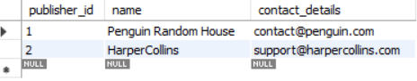

INSERT INTO Book (book_id, title, ISBL, edition, publication_year, price, publisher_id)
VALUES
(1, 'The Silent Patient', '9781250301697', 1, 2019, 499.99, 1),
(2, 'Atomic Habits', '9780735211292', 1, 2018, 399.50, 2),
(3, 'Clean Code', '9780132350884', 2, 2008, 699.00, 1);

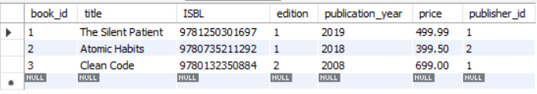

INSERT INTO Genere (genere_id, genere_name)
VALUES
(1, 'Thriller'),
(2, 'Self-help'),
(3, 'Programming');

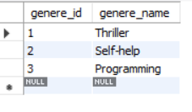

INSERT INTO Book_genere (book_id, genere_id)
VALUES
(1, 1), -- The Silent Patient -> Thriller
(2, 2), -- Atomic Habits -> Self-help
(3, 3); -- Clean Code -> Programming

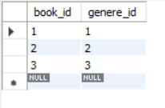

INSERT INTO Author (author_id, name, biography)
VALUES
(1, 'Alex Michaelides', 'British-Cypriot author.'),
(2, 'James Clear', 'Speaker and writer on habits.'),
(3, 'Robert C. Martin', 'Also known as Uncle Bob, software engineer.');

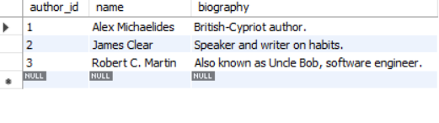

INSERT INTO Book_Author (book_id, author_id)
VALUES
(1, 1), -- The Silent Patient -> Alex
(2, 2), -- Atomic Habits -> James
(3, 3); -- Clean Code -> Robert

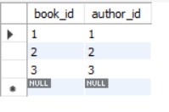

INSERT INTO Customer (customer_id, name)
VALUES
(1, 'Rachel Green'),
(2, 'Monica Geller');

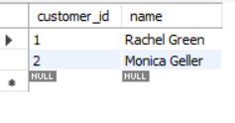

INSERT INTO Address (address_id, customer_id, street, city, state, country)
VALUES
(1, 1, '123 Park Ave', 'New York', 'NY', 'USA'),
(2, 2, '456 Central Perk', 'New York', 'NY', 'USA');

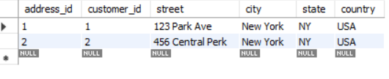

INSERT INTO Wishlist (customer_id, book_id)
VALUES
(1, 2), -- Rachel -> Atomic Habits
(1, 3), -- Rachel -> Clean Code
(2, 1); -- Monica -> The Silent Patient
(3, 'Clean Code', '9780132350884', 2, 2008, 699.00, 1);

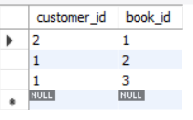

INSERT INTO Orderr (order_id, order_date, customer_id, payment_details, shipping_address_id)
VALUES
(1, '2025-06-01', 1, 'Credit Card', 1),
(2, '2025-06-02', 2, 'PayPal', 2);

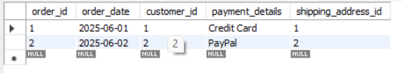

INSERT INTO Order_book (Orderitem_id, order_id, book_id, quantity)
VALUES
(1, 1, 2, 1), -- Rachel ordered Atomic Habits
(2, 1, 3, 1), -- Rachel also ordered Clean Code
(3, 2, 1, 2); -- Monica ordered 2 copies of The Silent Patient

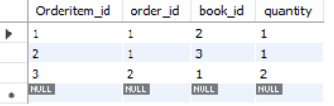

ER Diagram:

